

**Cloud Computing**

**Assignment 1B**

**Individual Report**

Xuan Tuan Minh Nguyen

103819212

# Table Of Contents

Table Of Contents 2

Introduction 3

*1.* *An introduction* 3

*2.* *Main purpose and objective of the report* 3

The Implementation of the project 3

*1.* *Overview of the given infrastructure diagram* 3

*2.* *The implementation* 4

2.1.1. The VPC 4

2.1.2. Security Groups 4

2.1.3. EC2 Virtual Machine 4

2.1.4. RDS Database Instance 4

2.1.5. Network ACL 4

2.2.1. Photo Storage 4

2.2.2. Photo meta-data in RDS Database 4

2.2.3. Photo Album Website functionality 4

*3.* *Technical details* 5

Website’s key features 5

*1.* *Enhancements* 5

Contribution 6

Conclusion 6

*1.* *Summary* 6

*2.* *Improvements* 6

# **Introduction**

## *An introduction*

Amazon Web Service, or AWS, is a service that is provided by Amazon which provide a spectrum of services that based on the mission of providing a transformative cloud computing platform that allows customers to use the empower of virtual machines to, for instance host a website, storing databases, etc. Beside from its foundation components are Amazon Elastic Compute Cloud (EC2) which provide a scalable virtual machines and Virtual Private Cloud (VPC) that enables custom network configurations. Amazon also introduces the Relational Database Services (RDS) and Simple Storage Service Bucket (S3 Bucket) which maximize the capability of storing databases over the cloud.

## *Main purpose and objective of the report*

In this project, I will demonstrate the use of EC2, VPC, RDS and S3 Bucket with a strict follow of the given infrastructure diagram to create a safe and displayable website that taken database from S3 bucket and display it through the EC2 instance. Additionally, I am also implement the network that banned any unauthorized connections to the instances.

# **The Implementation of the project**

## *Overview of the given infrastructure diagram*

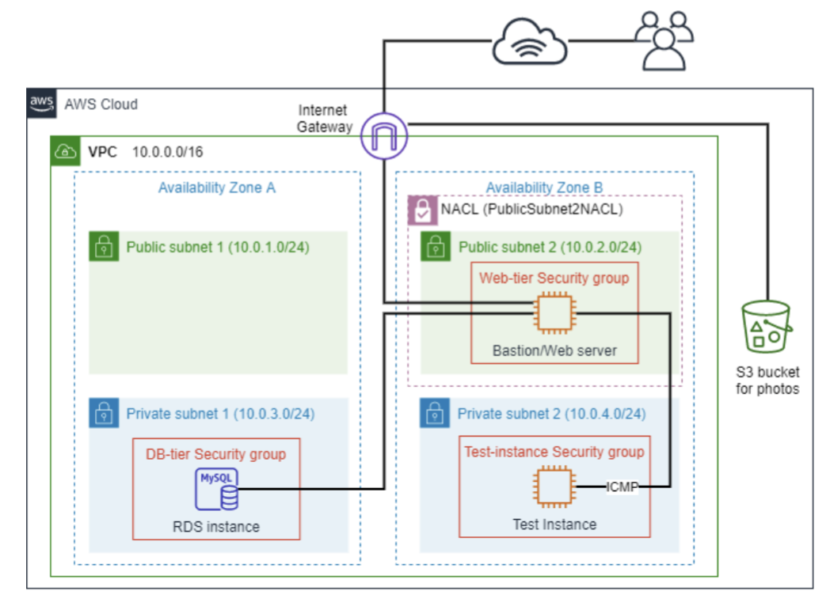

The diagram above illustrates the infrastructure that is required to be strictly implemented in order to create a safety network environment for the instances. There are four sub-networks inside the VPC that has a network of 10.0.0.0/16, which consists of two public subnet and 2 private subnets in two different availability zones. In addition, there are one main Bastion/Web server that allocated in the public subnet 2 (10.0.2.0/24) and two other instances that are allocated in the other two private subnets. In addition, there is a S3 bucket outside of the VPC that is also connected to the Internet Gateway.

## *The implementation*

### The VPC

In this step, I have created a Virtual Private Cloud infrastructure called XNguyenVPC, which consists of two Availability Zones (us-east-1a and us-east-1b) that holds two subnets (public and private). For the Public Subnet 2 in the Availability Zone B (10.0.2.0/24), I have attached it to the appropriate route table (XNguyenPublicRouteTable) that allows the subnet to interact with the internet gateway, allowing it to interact with the other VPCs and Internet. The other three will be route to the private route table and could only interact via the Public Subnet 2.

### Security Groups

There are three security groups, the first one is for the Test instance, which allows for all traffics from anywhere. The second one is made for the Bastion / Web server instance,

### EC2 Virtual Machine

### RDS Database Instance

### Network ACL

### Photo Storage

### Photo meta-data in RDS Database

### 2.2.3. Photo Album Website functionality

## *Result*

# **Website’s key features**

## *Enhancements*

There are three enhancements in our website, which are

* We've created a manager registration and login page with server-side validation rules that require a unique username and password and restrict access to users who have created accounts. For the registration portion, we used a variety of if-else conditions to determine if the user has provided the correct name, username, password, and authentication code (which is ilovecloudlabs). If the authentication code is correct, we push the user's information into the database and redirect them to the login page with a success message. If the username and password are not entered accurately three times on the login page, the login button will be disabled for five seconds.
* To prevent the user from gaining direct access to the database, we have added an if statement that checks if the user name and password on the login page are filled in; if they are not filled in and the user is logged out, the user is redirected to the login page.
* The third enhancement to this website is the ability for job descriptions to change dynamically, allowing the administrator to alter the job description at any time without manually altering the HTML code.

# **Contribution**

As a member, I have contributed to the development of two of the three specified website enhancements, namely the manager registration page and the login page with server-side validation that restricts access to users who have entered the correct username and password. I have also implemented a feature that prevents users from logging in for five seconds if they enter the incorrect username and password three times. In addition, I've added safeguards to prevent users from accessing the manager's page via direct addressing and after logging out. As the group's leader, I have effectively distributed the workload to each member and implemented solutions to the error code so that everything runs effortlessly.

# **Conclusion**

## *Summary*

To sum up, the report gives a general look at the implementation of the back-end side of our website, which is using PHP to validate data and interacting with server. Additionally, this report also focused on highlighting the purpose of each piece of code that we have written, as well as showing how we have created the enhancements for enhancing user’s experience.

## *Improvements*

Although we have addressed the majority of the initial assignment's flaws, this project still has room for development. As the number of users increases, the page's performance must also increase to maintain the same loading speed, thereby enhancing the user experience and preventing bottlenecks; for instance, caching optimisation and code profiling are the most prominent examples of this. In addition, it is essential to use third-party template engines, such as Twig or Smarty, that support template inheritance, variable interpolation, and conditional rendering to make the code more maintainable and flexible. Finally, a multi-factor authentication (MFA) is also needed to enhance the security for both login and register.